MINI PROJECT: Airline Reservation System

Aim:
The aim of an airline reservation system is to streamline the booking process for flights by enabling customers to search, select, and reserve tickets efficiently. It manages passenger details, flight schedules, and seat availability. The system also handles payments and generates e-tickets for convenience. Additionally, it ensures accuracy and improves operational efficiency for airlines.

Abstract:
An Airline Reservation System is designed to streamline the process of booking, managing, and canceling flight reservations. It allows users to search for flights based on destinations, dates, and preferences, and provides real-time availability of seats. The system automates seat selection, fare calculation, and payment processing. E-tickets are generated upon successful booking, ensuring convenience and security for passengers. Additionally, it manages passenger data and updates flight schedules in real-time. This improves operational efficiency and enhances customer satisfaction.

ERdiagram:

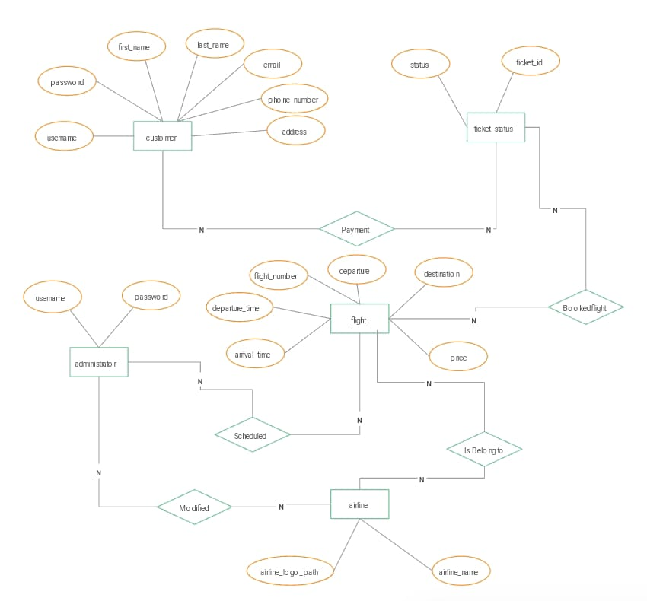

ER description:
ER diagram description:
Entities and Attributes:
- Customer:
  - Attributes: first_name, last_name, email, phone_number, address, username, password.
  - Connected to Ticket_Status and Payment relationships.
- Administrator:
  - Attributes: username, password.
  - Manages flight schedules via the Modified relationship.
- Flight:
  - Attributes: flight_number, departure_time, arrival_time, departure, destination, price.
  - Linked to Booked_Flight and belongs to an airline through the Is_Belong_to relationship.
- Airline:
  - Attributes: airline_name, airline_logo_path.
  - Connected to Flight.
- Ticket_Status:
  - Attributes: ticket_id, status.
  - Tracks the status of bookings.
- Payment:
  - Connected to Customer and linked with flight bookings.
Relationships:
- Payment: Facilitates booking by linking customers and flights.
- Booked_Flight: Represents a customer’s booked flights.
- Scheduled: Indicates the relationship between flights and administrators managing them.
- Modified: Allows administrators to modify flight details.
- Is_Belong_to: Associates flights with their respective airlines.
Code:
import javax.swing.*;
import java.sql.*;
public class AirlineManagementSystem {
private JFrame frame;
private JTextField txtFlightName, txtDeparture, txtDestination, txtSeatsAvailable;
private JTextArea txtAreaFlights;
private Connection conn;

public static void main(String[] args) {
SwingUtilities.invokeLater(() -> {
try {
new AirlineManagementSystem().frame.setVisible(true);
} catch (Exception e) {

e.printStackTrace();
}
});
}
public AirlineManagementSystem() {
frame = new JFrame("Airline Management System");
frame.setBounds(100, 100, 600, 400);
frame.setDefaultCloseOperation(JFrame.EXIT_ON_CLOSE);

frame.getContentPane().setLayout(new BorderLayout());
JPanel panel = new JPanel(new GridLayout(4, 2));
frame.getContentPane().add(panel, BorderLayout.NORTH);
panel.add(new JLabel("Flight Name:"));
panel.add(txtFlightName = new JTextField());
panel.add(new JLabel("Departure:"));
panel.add(txtDeparture = new JTextField());
panel.add(new JLabel("Destination:"));
panel.add(txtDestination = new JTextField());
panel.add(new JLabel("Seats Available:"));
panel.add(txtSeatsAvailable = new JTextField());

JButton btnAddFlight = new JButton("Add Flight");

btnAddFlight.addActionListener(e -> addFlight());
panel.add(btnAddFlight);

JButton btnViewFlights = new JButton("View Flights");
btnViewFlights.addActionListener(e -> viewFlights());
panel.add(btnViewFlights);

txtAreaFlights = new JTextArea();
frame.getContentPane().add(new JScrollPane(txtAreaFlights), BorderLayout.CENTER);
connectToDatabase();
}

private void connectToDatabase() {
try {
conn = DriverManager.getConnection("jdbc:mysql://localhost:3306/airline_db", "root", "");
} catch (SQLException e) {
e.printStackTrace();
}
}

private void addFlight() {
try {
String query = "INSERT INTO flights (flight_name, departure, destination, seats_available) VALUES (?, ?, ?, ?)";
PreparedStatement stmt = conn.prepareStatement(query);
stmt.setString(1, txtFlightName.getText());
stmt.setString(2, txtDeparture.getText());
stmt.setString(3, txtDestination.getText());
stmt.setInt(4, Integer.parseInt(txtSeatsAvailable.getText()));
stmt.executeUpdate();
JOptionPane.showMessageDialog(frame, "Flight Added!");
} catch (SQLException e) {
e.printStackTrace();
}
}
private void viewFlights() {

try {
String query = "SELECT * FROM flights";
Statement stmt = conn.createStatement();
ResultSet rs = stmt.executeQuery(query);
StringBuilder sb = new StringBuilder();
sb.append("Flight Name | Departure | Destination | Seats Available\n");
while (rs.next()) {
sb.append(rs.getString("flight_name")).append(" | ")
.append(rs.getString("departure")).append(" | ")
.append(rs.getString("destination")).append(" | ")
.append(rs.getInt("seats_available")).append("\n");
}
txtAreaFlights.setText(sb.toString());
} catch (SQLException e) {
e.printStackTrace();
}
}

Screenshot:

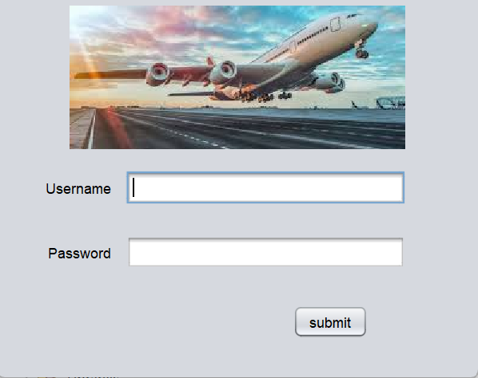
Figure 5.3.1

Login Page

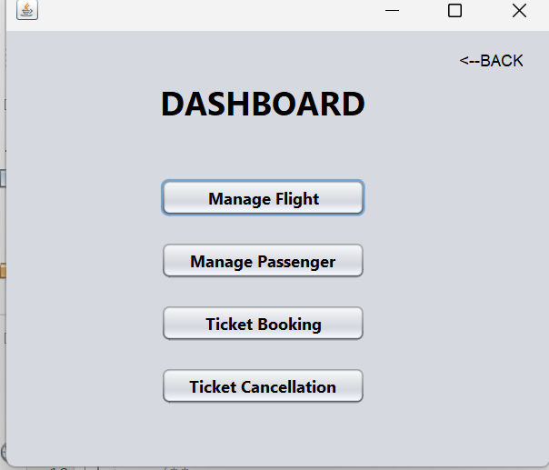
Figure 5.3.2

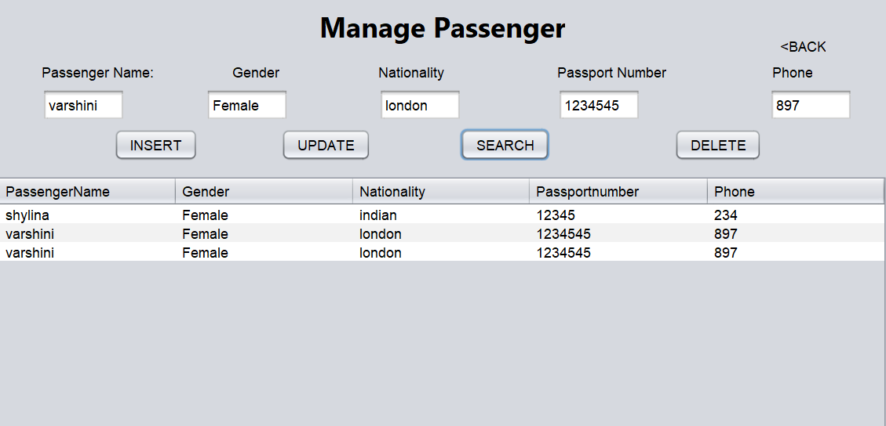
Figure 5.3.2

Insert Page

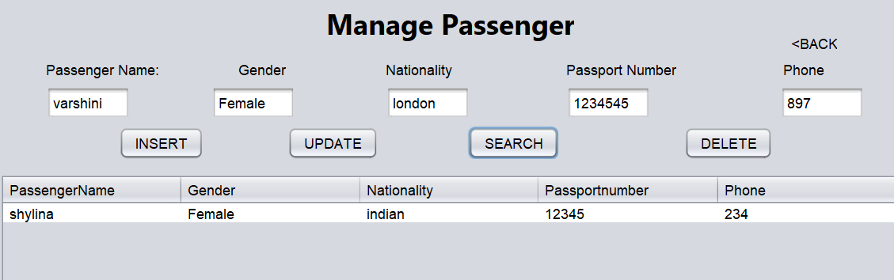
Figure 5.3.3

Delete Page

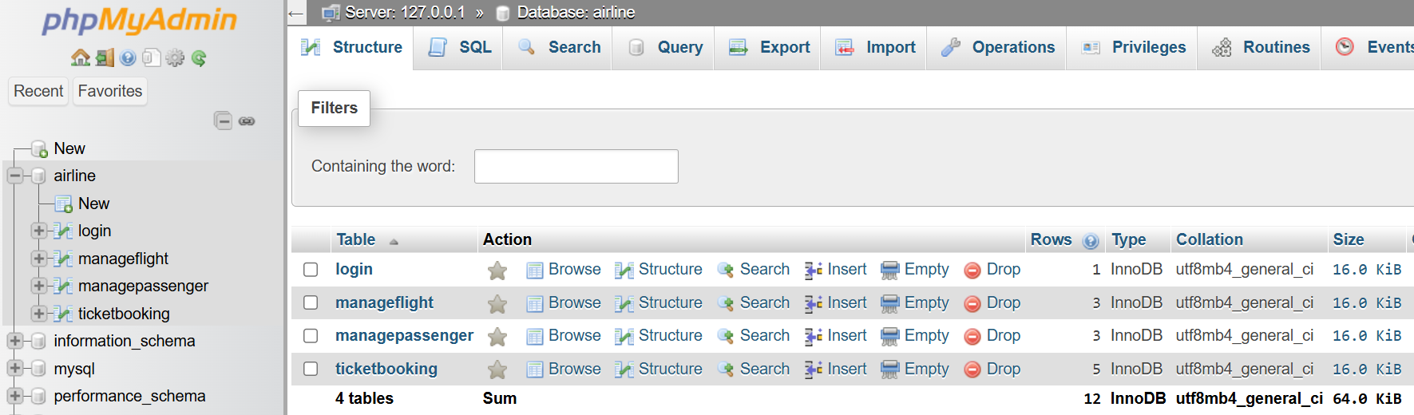

Figure 5.3.4

Conclusion

The Airline Management System (AMS) successfully met the key requirements of functionality, usability, and performance during User Acceptance Testing (UAT) and performance evaluations. Users appreciated its streamlined design, ease of navigation, and robust features for booking, flight management, and administrative tasks. However, areas for improvement, such as enhanced search functionality, a simplified refund process, and additional passenger-centric features, were identified to further enhance user satisfaction.

Overall, the AMS demonstrated its ability to handle high traffic and complex operations efficiently, making it a reliable solution for managing airline operations. With the suggested enhancements, the system is well-positioned to provide an even better user experience while meeting the demands of modern airline management.

